**Chemical Engineering Lab- II**

**Experiment-3**

**Group-5**

**Madhav Rathi (2018A1PS0723P)**

Himanshu Chaturvedi (2018A1PS0031P)

Himanshu Singh (2018A1PS0025P)

Gaurav Bellal Natesh (2018A1PS0027P)

Avish Goel (2018A1PS0734P)

**BITS Pilani**

**Experiment: 3**

**Rotary Vacuum Filter**

1. ***Aim:***

Study of cake filtration using continuous vacuum filter such as rotary drum filter

1. ***Objective:***

* To study the construction and operation of rotary drum filter
* Determine the specific cake resistance and filter medium resistance for CaCO3 slurry

1. ***Observations:***

| **Constant Parameters** | |
| --- | --- |
| Drum Dia | 350 mm |
| Drum Length | 450 mm |
| Rotation Speed | 1.5 rpm |
| Viscosity | .001 kg/m s |

| **Set No** | **Slurry conc. (wt %)** | **Vacuum pressure** | **Time (s)** | **Liquid level in the filtrate tank (cm)** | **Weight (g)** | |
| --- | --- | --- | --- | --- | --- | --- |
| **Wet Cake** | **Dry Cake** |
| 1 | 10% | 200 mm Hg | 15 | 1 | 95 | 89 |
|  |  |  | 33 | 2 |
|  |  |  | 54 | 3 |
|  |  |  | 69 | 4 |
|  |  |  | 91 | 5 |
|  |  |  | 108 | 6 |
|  |  |  | 128 | 7 |
|  |  |  | 152 | 8 |
|  |  |  | 174 | 9 |
|  |  |  | 206 | 10 |

| **Set No** | **Slurry conc. (wt %)** | **Vacuum pressure** | **Time (s)** | **Liquid level in the filtrate tank (cm)** | **Weight (g)** | |
| --- | --- | --- | --- | --- | --- | --- |
| **Wet Cake** | **Dry Cake** |
| 1 | 10% | 400 mm Hg | 8 | 1 | 98 | 93 |
|  |  |  | 15 | 2 |
|  |  |  | 27 | 3 |
|  |  |  | 35 | 4 |
|  |  |  | 41 | 5 |
|  |  |  | 51 | 6 |
|  |  |  | 59 | 7 |
|  |  |  | 70 | 8 |
|  |  |  | 78 | 9 |
|  |  |  | 89 | 10 |

1. ***Sample Calculations:***

$We need to find the values of α \& R_{m} for both cases$

$μ = 0.001 Kg/m.s ; A = πDL = 3.14*0.35*0.45 = 0.49455 m^{2}$

**Case 1: For Vacuum Pressure of 200 mg**

$We make a plot of t/V v/s V for the data points given in the experiment$

$Based on the plot and the trendline, we observe that the equation of t/V v/s V is:$

$t/V =2*10^{6}V + 30824$

$Comparing with General Equation t/V = K_{C}/2*V + 1/q_{0}$

$K_{c}/2 = 2*10^{6} and 1/q_{0} = 30824$

$K_{C}=(μαc)/(A^{2}ΔP) and 1/q_{0}=μR_{m}/(AΔP)$

$Mass of Wet Cake (m_{F}) =95 -64 = 31g ; Mass of Dry Cake = 89-64 =25g$

$Concentration of Solids in Feed Slurry c_{s} = 5*1000/45 = 111.11 kg/m^{3}$

$Calculating C: c = c_{s}/((1-((m_{F}/m_{c}))*c_{s}/ρ = 111.11/(((1-((31/25))*111.11/1000)$

$c = 114.154 kg/m^{3}$

**Calculation of $α$ and R_m using the equation and the constant parameters.**

**Specific Cake Resistance:**

$α = K_{c}*A^{2}*ΔP/(c*μ) = (4*10^{6}*0.49455^{2}*26674.088)/(114.154*0.001)$

$α = 2.2860138 *10^{11} m/Kg$

**Filter Medium Resistance**

$R_{m}=A*ΔP*(1/q_{0})/μ = 0.49455*26674.088*30824/0.001$

$R_{m} =4.0662*10^{11} m^{-1}$

**Case 2: For Vacuum Pressure of 400 mg**

$We make a plot of t/V v/s V for the data points given in the experiment$

$Based on the plot and the trendline, we observe that the equation of t/V v/s V is:$

$t/V =665445V + 14608$

$Comparing with General Equation t/V = K_{C}/2*V + 1/q_{0}$

$K_{c}/2 = 665445 and 1/q_{0} = 14608$

$K_{C}=(μαc)/(A^{2}ΔP) and 1/q_{0}=μR_{m}/(AΔP)$

$Mass of Wet Cake (m_{F}) =98 -64 = 34g ; Mass of Dry Cake = 93-64 =29g$

$Concentration of Solids in Feed Slurry c_{s} = 5*1000/45 = 111.11 kg/m^{3}$

$Calculating C: c = c_{s}/((1-((m_{F}/m_{c}))*c_{s}/ρ = 111.11/(((1-((34/29))*111.11/1000)$

$c = 113.28 kg/m^{3}$

**Calculation of $α$ and R_m using the equation and the constant parameters.**

**Specific Cake Resistance:**

$α = K_{c}*A^{2}*ΔP/(c*μ) = (1330890*0.49455^{2}*53348.176)/(113.28*0.001)$

$α = 1.53295 *10^{11} m/Kg$

**Filter Medium Resistance**

$R_{m}=A*ΔP*(1/q_{0})/μ = 0.49455*53348.176*14608/0.001$

$R_{m} =3.854*10^{11} m^{-1}$

1. ***Results and Discussions:***

For vacuum pressure of 200 mm Hg

| **Time, t (s)** | **Liquid level in the filtrate tank, V (cm)** | **V** | **t/V** |
| --- | --- | --- | --- |
|
| 15 | 1 | 0.0005 | 30000 |
| 33 | 2 | 0.001 | 33000 |
| 54 | 3 | 0.0015 | 36000 |
| 69 | 4 | 0.002 | 34500 |
| 91 | 5 | 0.0025 | 36400 |
| 108 | 6 | 0.003 | 36000 |
| 128 | 7 | 0.0035 | 36571.42857 |
| 152 | 8 | 0.004 | 38000 |
| 174 | 9 | 0.0045 | 38666.66667 |
| 206 | 10 | 0.005 | 41200 |

Plot of t/V vs V:

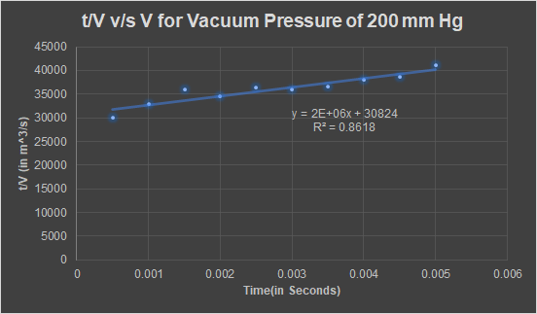

| **Parameter** | **Value in SI** |
| --- | --- |
| Area | 0.49455 |
| Pressure Difference | 26673.816 |
| c_s | 111.1111111 |
| m_F | 31 |
| m_c | 25 |
| c | 114.1552511 |
| K_c | 4000000 |
| 1/q0 | 30824 |
| Results | |
| **alpha** | **2.2859*1011 m/kg** |
| **R_m** | **4.066*1011  m-1** |

The theoretically expected values of the Filter medium resistance, as per general trends in literature, is expected to be around 1011 m-1 and the value computed after the experiment also happens to be in the same range.

For vacuum pressure of 400 mm Hg

| **Time, t (s)** | **Liquid level in the filtrate tank, V (cm)** | **V** | **t/V** |
| --- | --- | --- | --- |
|
| 8 | 1 | 0.0005 | 16000 |
| 15 | 2 | 0.001 | 15000 |
| 27 | 3 | 0.0015 | 18000 |
| 35 | 4 | 0.002 | 17500 |
| 41 | 5 | 0.0025 | 16400 |
| 51 | 6 | 0.003 | 17000 |
| 59 | 7 | 0.0035 | 16857.14286 |
| 70 | 8 | 0.004 | 17500 |
| 78 | 9 | 0.0045 | 17333.33333 |
| 89 | 10 | 0.005 | 17800 |

Plot of t/V vs V:

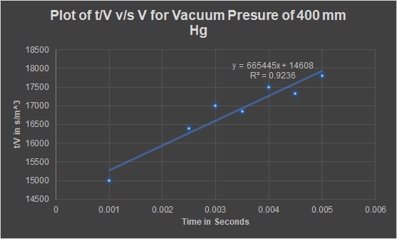

For the above case, vacuum pressure = 400 mm Hg, a lot of outliers existed in the experimental data, which resulted in a very poor linear fit. To improve upon this, 3 such points that appeared to be very skewed as a result of experimental errors were removed and the above plot is the result of this data cleaning. The resultant linear fit was much better than the original fit.

The theoretically expected values of the Filter medium resistance, as per general trends in literature, is expected to be around 1011 m-1 and the value computed after the experiment also happens to be in the same range.

**Derivation of equation (4):**

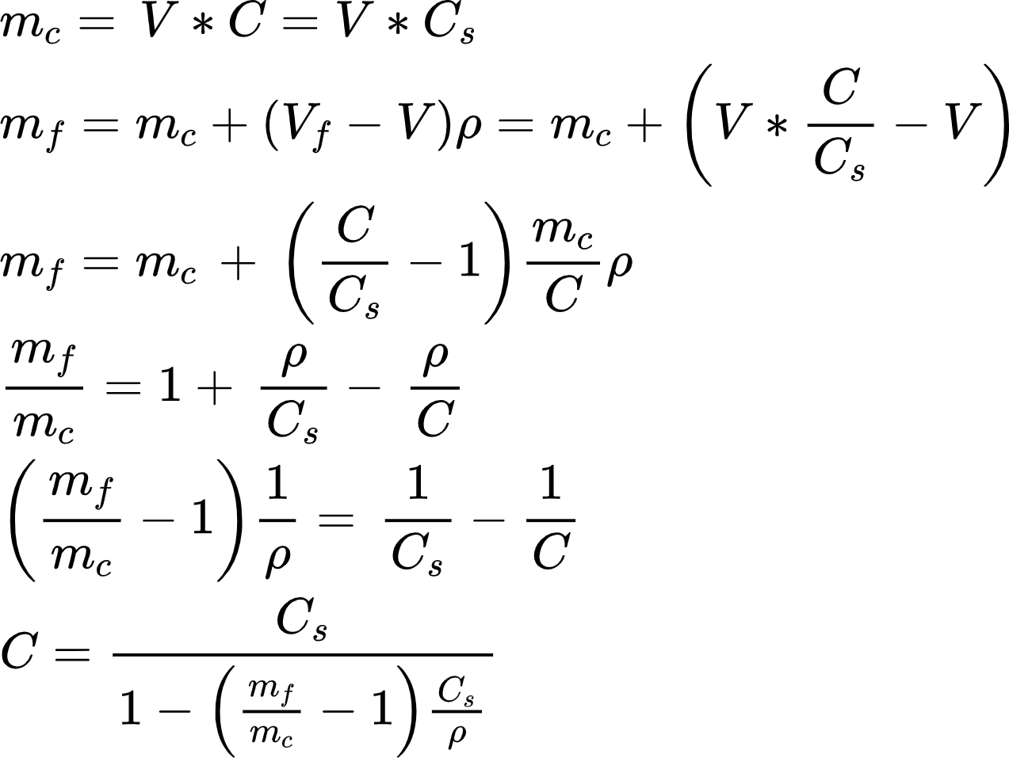

Where,

C = mass of particles deposited in the filter per unit volume of filtrate

Cs = mass of solid in the feed per unit volume of liquid fed

V = volume of filtrate collected in time t

𝑉𝐹 = volume of liquid fed in time t

𝑚𝑐 = weight of dry cake

𝑚𝐹 = weight of wet cake

**Significance of Ergun Equation:**

The Ergun equation is used to calculate the pressure drop when across a packed bed of solid particles. It is the base equation used in deriving the equation (1). In this case, the filter cake acts a packed bed and the pressure drop across the bed is equated to the known pressure drop of the rotary drum filter.

1. ***Conclusion:***

* For a vacuum pressure of 200 mm Hg, the specific cake resistance comes out to be **2.2859*1011 m/kg** and the Filter Medium Resistance is **4.066*1011  m-1**
* For a vacuum pressure of 400 mm Hg, the specific cake resistance comes out to be **1.5329*1011 m/kg** and the Filter Medium resistance is **3.854*1011 m-1**